Faraday bags

# **Shieldster key fob Faraday bags**

**Description ⬇️**

⚙️ Faraday bag intended for car key security and data protection of tiny gadgets. It is also used to block radio frequency transmissions for forensics, military, executive travel, personal security, and EMP protection.

⚙️ Two layers of high quality shielding Faraday fabric used to manufacture a Faraday bags.

⚙️ Fabric used for Shieldster Faraday Bags.

**Diamond Form Faraday Fabric:**

Durable, Conductive Fabric interwoven with copper and nickel fibers.

Long lasting fabric with signal blocking capabilities.

**BALLISTIC NYLON:**

Durable, Rugged and Tough Nylon Fabric with a 2x2 basket weave design for high tensile strength and tear resistance.

Coated with Polyurethane with water repellent properties.

⚙️ Ballistic nylon exterior fabrics that are water-resistant.

⚙️ Double roll security and Velcro fastening.

**Content⬇️**

⚙️ Shildster Vertical Faraday bags blocks WiFi (2.4 & 5GHz), Bluetooth, mobile signals (including 5G networks), GPS, RFID, NFC, and radio frequencies from low MHz to 40GHz.

⚙️ It also shields against EMI, EMR, and EMF radiation.

⚙️ Size:

External:19.5cm - length & 13.5cm - iwidth

Internal: 10.5cm -length & 10.5cm - width

⚙️ Suitable for storing

* Key Fobs
* Building access cards
* Credit cards
* Small phones
* IDs
* Smart watches
* Transmitters
* WiFi cards
* Crypto cold wallets

## **Shieldster Vertical non window Faraday bag for mobile**

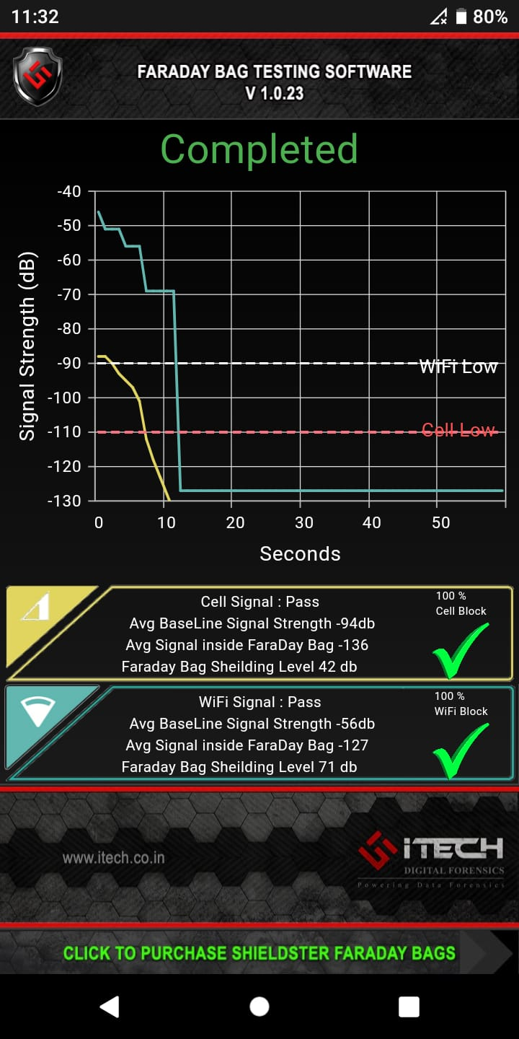

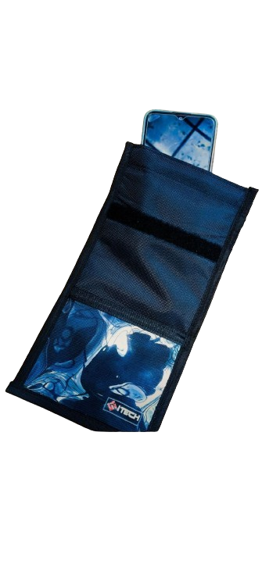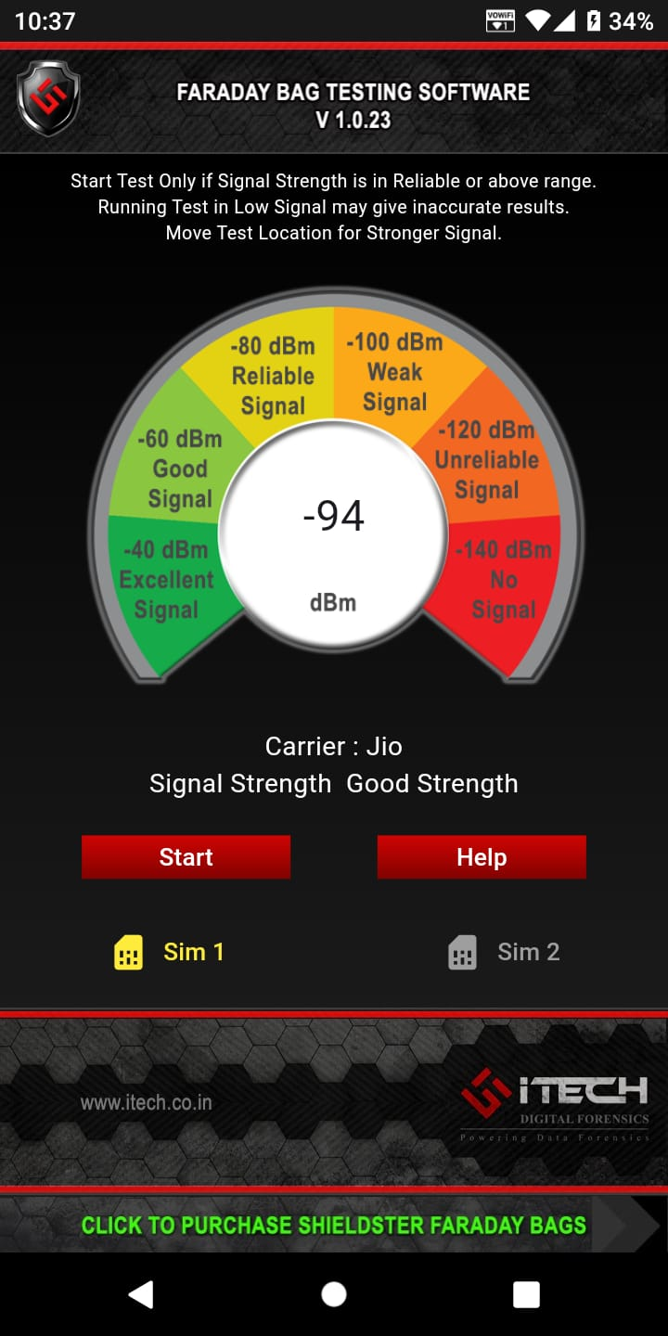

**Description ⬇️**

⚙️ The vertical non window Faraday bags for Phones fully blocks all wireless signals, shielding small electronic devices from tracking, hacking, and spying.

⚙️ Two layers of high quality shielding Faraday fabric used to manufacture a Faraday bags.

⚙️ Fabric used for Shieldster Faraday Bags.

**Diamond Form Faraday Fabric:**

* Durable, Conductive Fabric interwoven with copper and nickel fibers.
* Long lasting fabric with signal blocking capabilities.

**BALLISTIC NYLON:**

* Durable, Rugged and Tough Nylon Fabric with a 2x2 basket weave design for high tensile strength and tear resistance.
* Coated with Polyurethane with water repellent properties.

⚙️ Transparent pockets for holding little items like cards.

⚙️ Ballistic nylon exterior fabrics that are water-resistant.

⚙️ Double roll security and Velcro fastening.

⚙️ The large opening may accept any size of cell phone.

**Content⬇️**

⚙️ Shildster Vertical Faraday bags blocks WiFi (2.4 & 5GHz), Bluetooth, mobile signals (including 5G networks), GPS, RFID, NFC, and radio frequencies from low MHz to 40GHz.

⚙️ It also shields against EMI, EMR, and EMF radiation.

⚙️ Size:

**External:** 29 cm - length & 15.5 cm - width

**Internal:** 19cm -length & 13cm - width

⚙️ Suitable for storing

* cell phones
* GPS units
* Passports
* smart watches
* Building access cards
* keyfobs
* Credit cards transmitters
* Two-way radios.

## **Shieldster Horizontal non window Faraday bag for mobile**

**Description ⬇️**

**⚙️** The Horizontal non window Faraday bags for Phones. It fully blocks all wireless signals, shielding small electronic devices from tracking, hacking, and spying.

⚙️ Two layers of high quality shielding Faraday fabric used to manufacture a Faraday bags.

⚙️ Fabric used for Shieldster Faraday Bags.

**Diamond Form Faraday Fabric:**

* Durable, Conductive Fabric interwoven with copper and nickel fibers.
* Long lasting fabric with signal blocking capabilities.

**BALLISTIC NYLON:**

* Durable, Rugged and Tough Nylon Fabric with a 2x2 basket weave design for high tensile strength and tear resistance.
* Coated with Polyurethane with water repellent properties.

⚙️ Transparent pockets for holding little items like cards.

⚙️ Ballistic nylon exterior fabrics that are water-resistant.

⚙️ Double roll security and Velcro fastening.

⚙️ The large opening may accept any size of cell phone.

**Content⬇️**

⚙️ Shildster Horizontal Faraday bags blocks WiFi (2.4 & 5GHz), Bluetooth, mobile signals (including 5G networks), GPS, RFID, NFC, and radio frequencies from low MHz to 40GHz.

⚙️ It also shields against EMI, EMR, and EMF radiation.

⚙️ Size:

**External:** 24cm - length & 24cm - width

**Internal:** 15.5cm -length & 22cm - width

⚙️ Suitable for storing

* cell phones
* GPS units
* Passports
* smart watches
* Building access cards
* key fobs
* Credit cards transmitters
* Two-way radios.

## **Shieldster Horizontal Window Faraday bags for mobile**

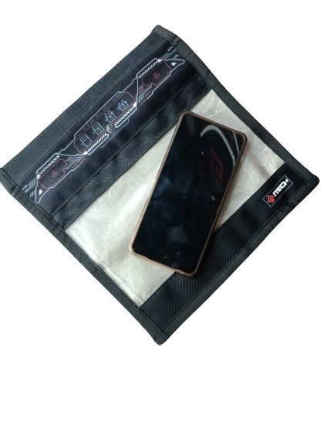



**Description ⬇️**

⚙️ Shieldster horizontal window Faraday bags for Phones, fully blocks all wireless signals, shielding small electronic devices from tracking, hacking, and spying.

⚙️ The wide preview window allows the user to see the items inside, the device's battery life, and confirm signal termination. It does not allow you to control touch displays through the window.

⚙️ Two layers of high quality shielding Faraday fabric used to manufacture a Faraday bags.

⚙️ Fabric used for Shieldster Faraday Bags.

**Diamond Form Faraday Fabric:**

* Durable, Conductive Fabric interwoven with copper and nickel fibers.
* Long lasting fabric with signal blocking capabilities.

**BALLISTIC NYLON:**

* Durable, Rugged and Tough Nylon Fabric with a 2x2 basket weave design for high tensile strength and tear resistance.
* Coated with Polyurethane with water repellent properties.

⚙️ Transparent pockets for holding little items like cards.

⚙️ Ballistic nylon exterior fabrics that are water-resistant.

⚙️ Double roll security and Velcro fastening.

⚙️ The large opening may accept any size of cell phone.

**Content⬇️**

(Transparent sheet)

⚙️ Shildster Vertical Faraday bags blocks WiFi (2.4 & 5GHz), Bluetooth, mobile signals (including 5G networks), GPS, RFID, NFC, and radio frequencies from low MHz to 40GHz.

⚙️ It also shields against EMI, EMR, and EMF radiation.

⚙️ Suitable for storing

* Cell phones
* GPS units
* Passports
* Smart watches
* Building access cards
* keyfobs
* Credit cards transmitters
* Two-way radios.

# **Shieldster Faraday bags for Tablets**

**Description ⬇️**

⚙️ Shieldster Non-Windows Faraday Bag for Tablets. It completely filters all wireless signals, keeping electronic equipment safe from tracking, hacking, and spying.

⚙️ Two layers of high quality shielding Faraday fabric used to manufacture a Faraday bags.

⚙️ Fabric used for Shieldster Faraday Bags.

**Diamond Form Faraday Fabric:**

* Durable, Conductive Fabric interwoven with copper and nickel fibers.
* Long lasting fabric with signal blocking capabilities.

**BALLISTIC NYLON:**

* Durable, Rugged and Tough Nylon Fabric with a 2x2 basket weave design for high tensile strength and tear resistance.
* Coated with Polyurethane with water repellent properties.

⚙️ Transparent pockets for holding little items like cards.

⚙️ Ballistic nylon exterior fabrics that are water-resistant.

⚙️ Double roll security and Velcro fastening.

**Content⬇️**

⚙️ Shildster Vertical Faraday bags blocks WiFi (2.4 & 5GHz), Bluetooth, mobile signals (including 5G networks), GPS, RFID, NFC, and radio frequencies from low MHz to 40GHz.

⚙️ It also shields against EMI, EMR, and EMF radiation.

⚙️ Size:

**External:** 39.5cm - length & 25.5cm - width

**Internal:** 30cm -length & 23cm - width

⚙️ Suitable for storing

* Tablets
* eReaders
* Multiple cell phones
* Transponders
* Transmitters
* GPS units
* Smart home appliances
* Two-way radios
* Hard drives
* Digital cameras
* Passports

# **Shieldster Faraday bag for laptops**

**Description ⬇️**

⚙️ Shieldster Non Windows Faraday Bag for laptops completely filters all wireless signals, keeping electronic equipment safe from tracking, hacking, and spying.

⚙️ Two layers of high quality shielding Faraday fabric used to manufacture a Faraday bags.

⚙️ Fabric used for Shieldster Faraday Bags.

**Diamond Form Faraday Fabric:**

* Durable, Conductive Fabric interwoven with copper and nickel fibers.
* Long lasting fabric with signal blocking capabilities.

**BALLISTIC NYLON:**

* Durable, Rugged and Tough Nylon Fabric with a 2x2 basket weave design for high tensile strength and tear resistance.
* Coated with Polyurethane with water repellent properties.

⚙️ Transparent pockets for holding little items like cards.

⚙️ Ballistic nylon exterior fabrics that are water-resistant.

⚙️ Double roll security and Velcro fastening.

**Content⬇️**

⚙️ Shildster Vertical Non window Faraday bags blocks WiFi (2.4 & 5GHz), Bluetooth, mobile signals (including 5G networks), GPS, RFID, NFC, and radio frequencies from low MHz to 40GHz.

⚙️ It also shields against EMI, EMR, and EMF radiation.

⚙️ Size:

**External:** 56cm - length & 38cm - width

**Internal:** 47cm -length & 35cm - width

⚙️ Suitable for storing

* Laptops
* Multiple tablets
* Multiple cell phones
* Transmitters
* Two-way radios
* Wireless enabled smart home appliances
* Digital cameras
* GPS units.

# **Shieldster Power Bank Faraday bags for mobile**

**Description ⬇️**

⚙️ Shieldster Window Power Bank Faraday Bag for mobile completely filters all wireless signals, keeping electronic equipment safe from tracking, hacking, and spying.

⚙️ Two layers of high quality shielding Faraday fabric used to manufacture a Faraday bags.

⚙️ Fabric used for Shieldster Faraday Bags.

**Diamond Form Faraday Fabric:**

Durable, Conductive Fabric interwoven with copper and nickel fibers.

Long lasting fabric with signal blocking capabilities.

**BALLISTIC NYLON:**

Durable, Rugged and Tough Nylon Fabric with a 2x2 basket weave design for high tensile strength and tear resistance.

Coated with Polyurethane with water repellent properties.

⚙️ Transparent pockets for holding little items like cards.

⚙️ Ballistic nylon exterior fabrics that are water-resistant.

**Content⬇️**

**⚙️** Suitable for storing

* cell phones
* GPS units
* Passports
* smart watches
* Building access cards
* keyfobs
* Credit cards transmitters
* Two-way radios.